In 10th grade, I took *Biology*

Population Growth as a function of Temperature

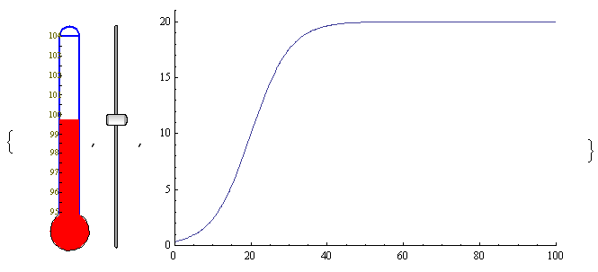

In reality, many biotic and abiotic factors affect a population’s growth. This simple model shows how a population’s growth over time would be affected by fluctuations away from its ideal temperature.

I learned that a hypothetical population subject to a temperature of 99.75 degrees reaches carrying capacity in around 40 years.